

Blood Bank

**Submitted to:**

Dr. Karim Mohammed Rezaul  
Adjunct Professor  
Department of Computer Science and Engineering  
Faculty of Science and Information Technology

**Submitted by:**

Group# 8

Nowroz Islam  
163-15-8484  
nowroz15-8484@diu.edu.bd

Md. Abir Hassan Zoha  
163-15-8482  
abir15-8482@diu.edu.bd

Section-D  
Database Management System Lab  
Fall 2018

*Project Report*

Application Access

Username Password

admin 12345

dataoperator 98765

Contents

1. Database Relationship
2. Database Tables

* tblAddress
* tblBilling
* tblBloodReceive
* tblBloodTest
* tblCrossMatch
* tblDonation
* tblFunding
* tblMedicalCondition
* tblMedication
* tblPerson
* tblProduct
* tblPurchase
* tblSalary
* tblStaff
* tblStaffCategory
* tblTransaction

1. Query

* qryBloodStock
* qryFunding
* qryMemberList
* qryMonthlySalary
* qryPendingBloddTest
* qryPendingCrossMatch
* qryPurchase
* qrySalaryRecord
* qryTransaction
* qryUpdateCrossMatch
* qryUptedTest

1. Form

* frmAccountManager
* frmBloodReceive
* frmDonation
* frmFund
* frmMember
* frmProducts
* frmPurchase
* frmSalary
* frmStaffs
* frmTestReport
* frmTransaction
* frmUpdateCrossMatch
* subfrmAddNewSalary
* subfrmAddress
* subfrmMonthlySalary
* subfrmPerson
* subfrmSalaryRecord
* subfrmStaffCategory

1. Login Page
2. Admin Page
3. Data Entry Operator Page
4. Report

* rptBloodTest
* rptCrossMatch
* rptFunding
* rptMonthlySalary
* rptPurchase
* rptTransaction

Relationship

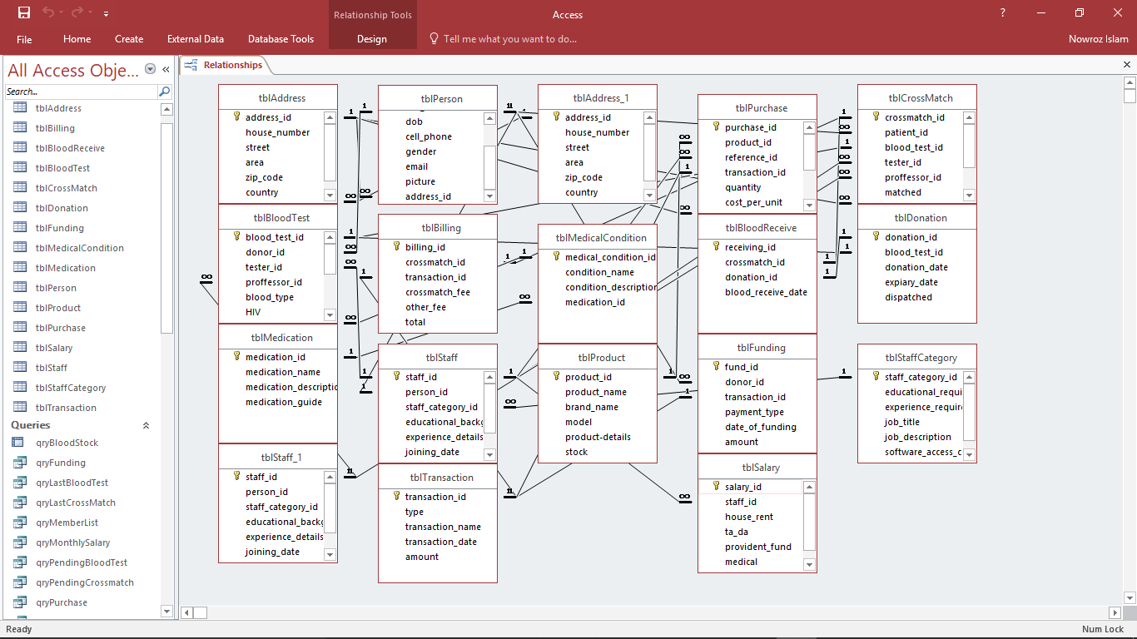Relationship between databases tables.

Database Tables

# Table: tblAddress

# Table: tblBilling

# Table: tblBloodReceive

# Table: tblBloodTest

# Table: tblCrossMatch

# Table: tblDonation

# Table: tblFunding

# Table: tblMedicalCondition

# Table: tblMedication

# Table: tblPerson

# Table: tblProduct

# Table: tblPurchase

# Table: tblSalary

# Table: tblStaff

# Table: tblStaffCategory

# Table: tblTransaction

Queries

# Query: qryBloodStock

# Query: qryFunding

# Query: qryMemberList

# Query: qryMonthlySalary

# Query: qryPendingBloodTest

# Query: qryPendingCrossMatch

# Query: qryPurchase

# Query: qrySalaryRecord

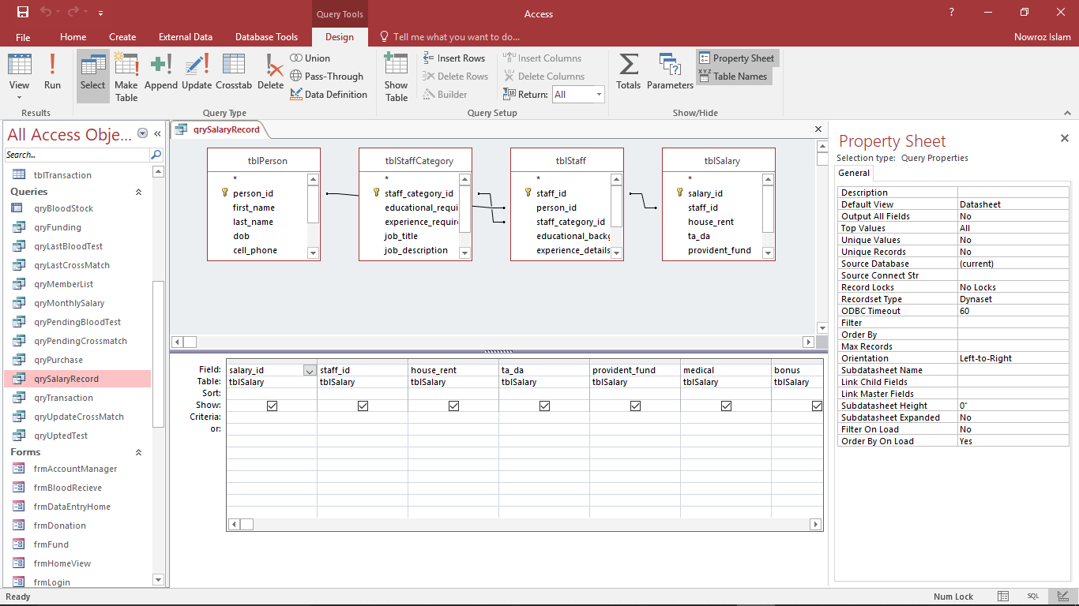

# Query: qryTransaction

# Query: qryUpdateCrossMatch

# Query: qryUptedTest

Forms

# Form: frmBloodReceive

# Form: frmDonation

# Form: frmFund

# Form: frmMember

# Form: frmProducts

# Form: frmPurchase

# Form: frmSalary

# Form: frmStaffs

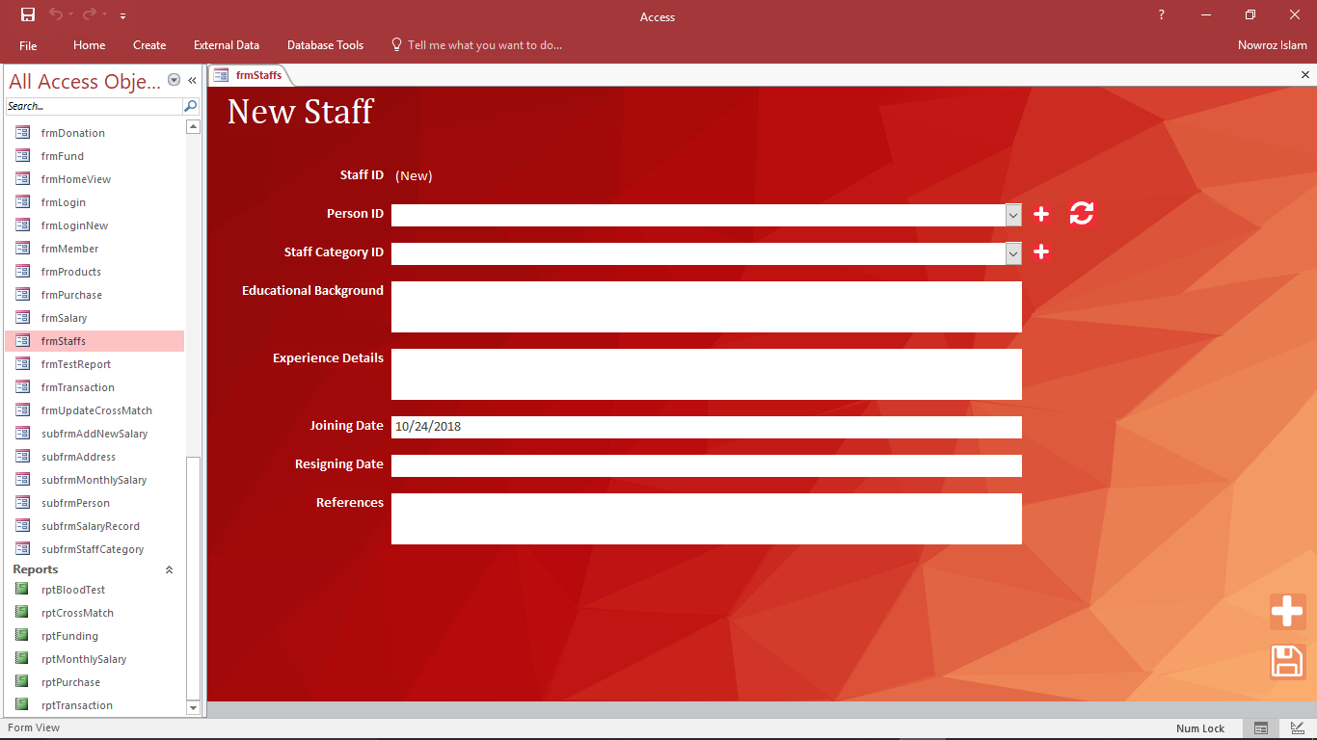

# Form: frmTestReport

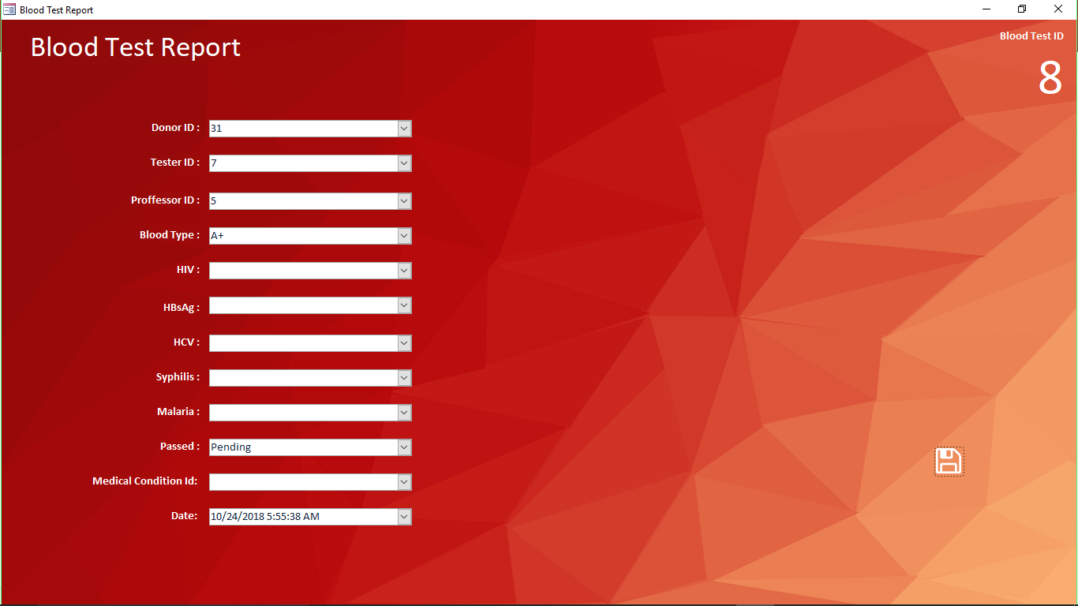

# Form: frmTransaction

# Form: frmUpdateCrossMatch

# Form: subfrmAddNewSalary

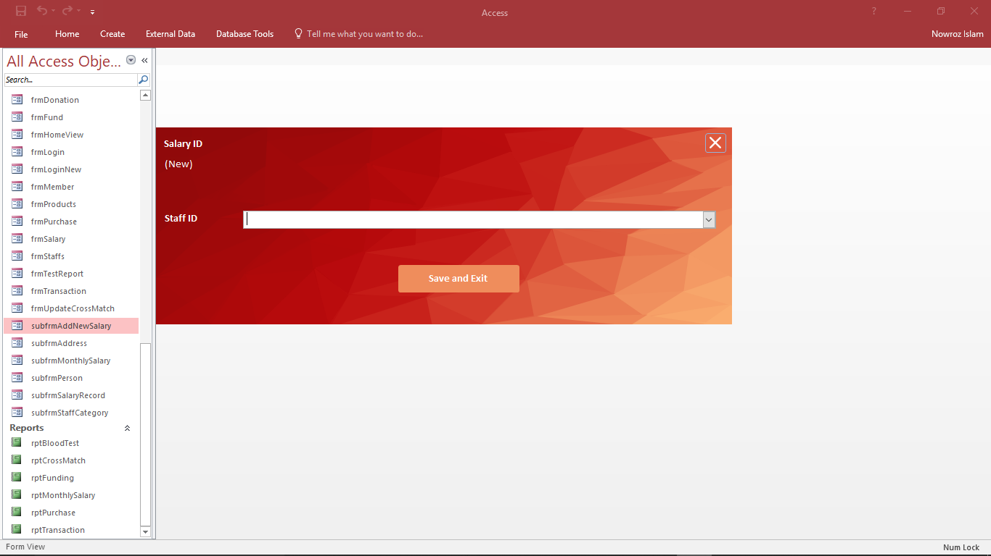

# Form: subfrmAddress

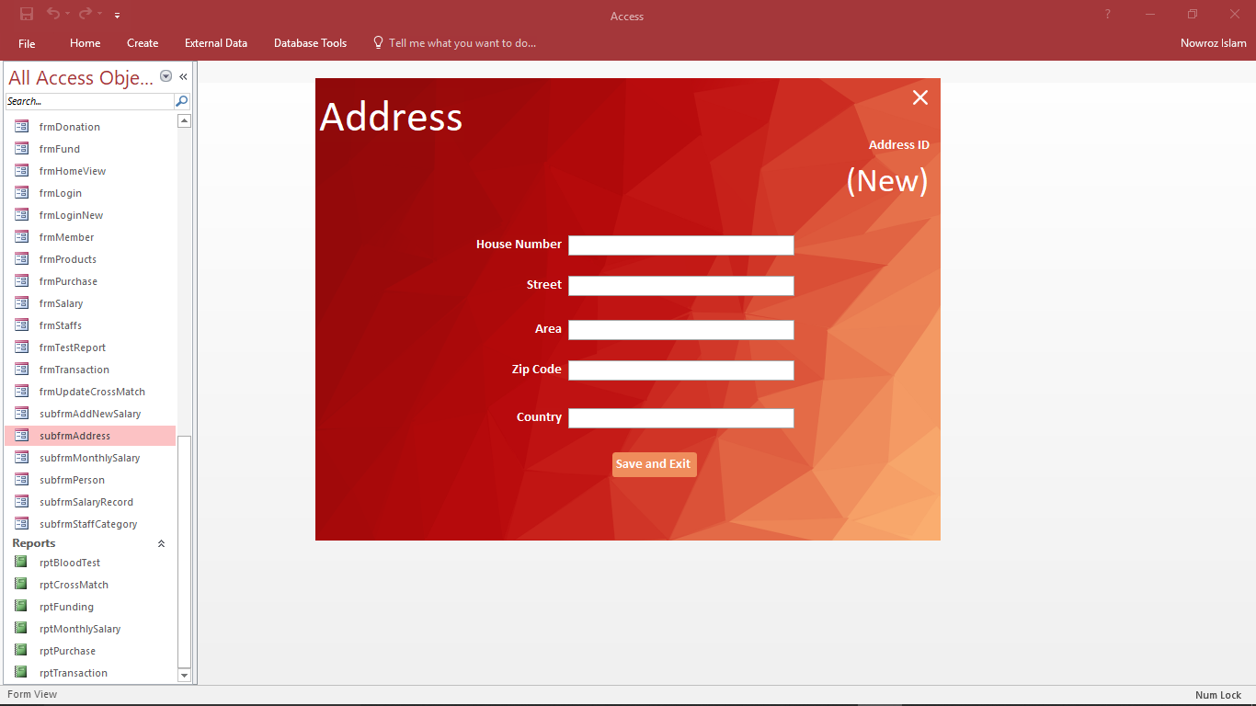

# Form: subfrmMonthlySalary

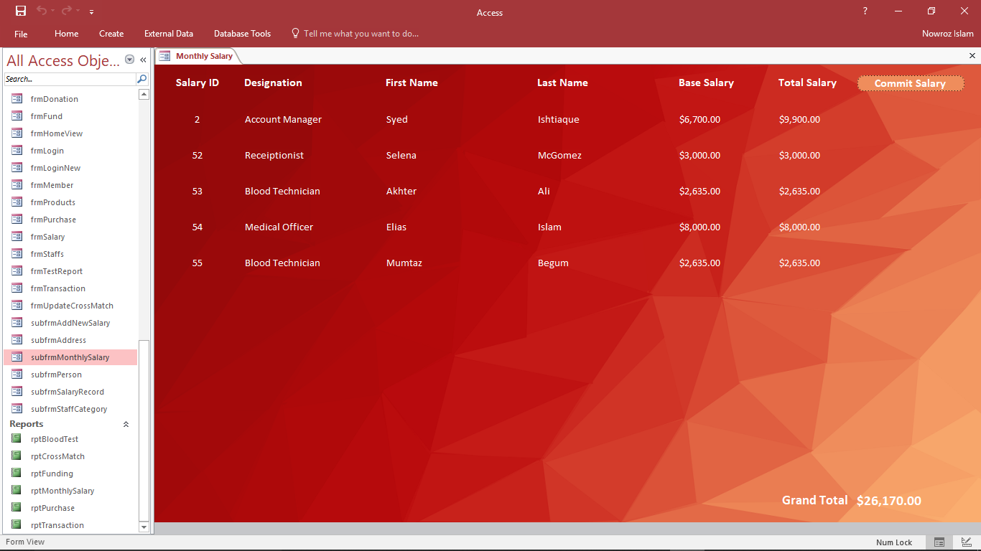

# Form: subfrmPerson

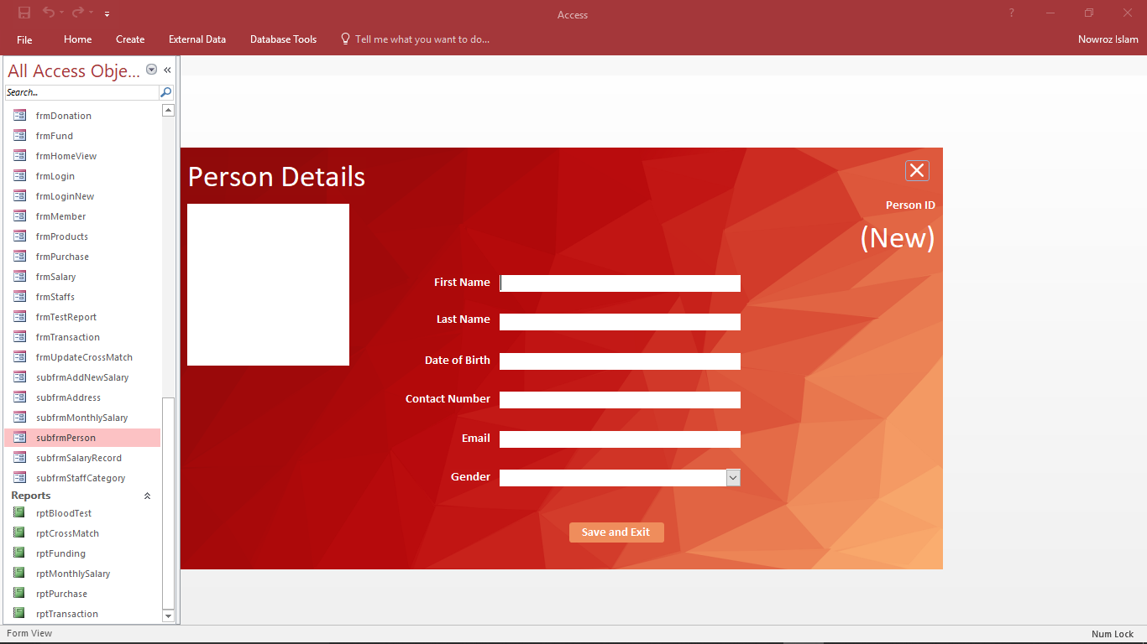

# Form: subfrmSalaryRecord

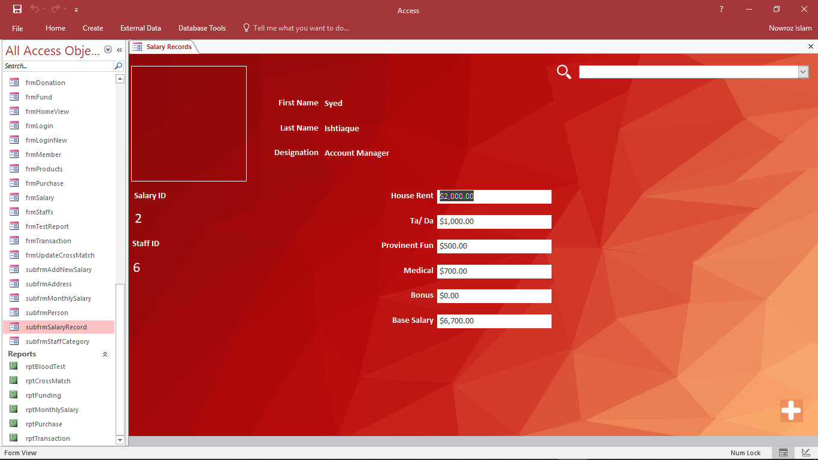

# Form: subfrmNewStaffCategory

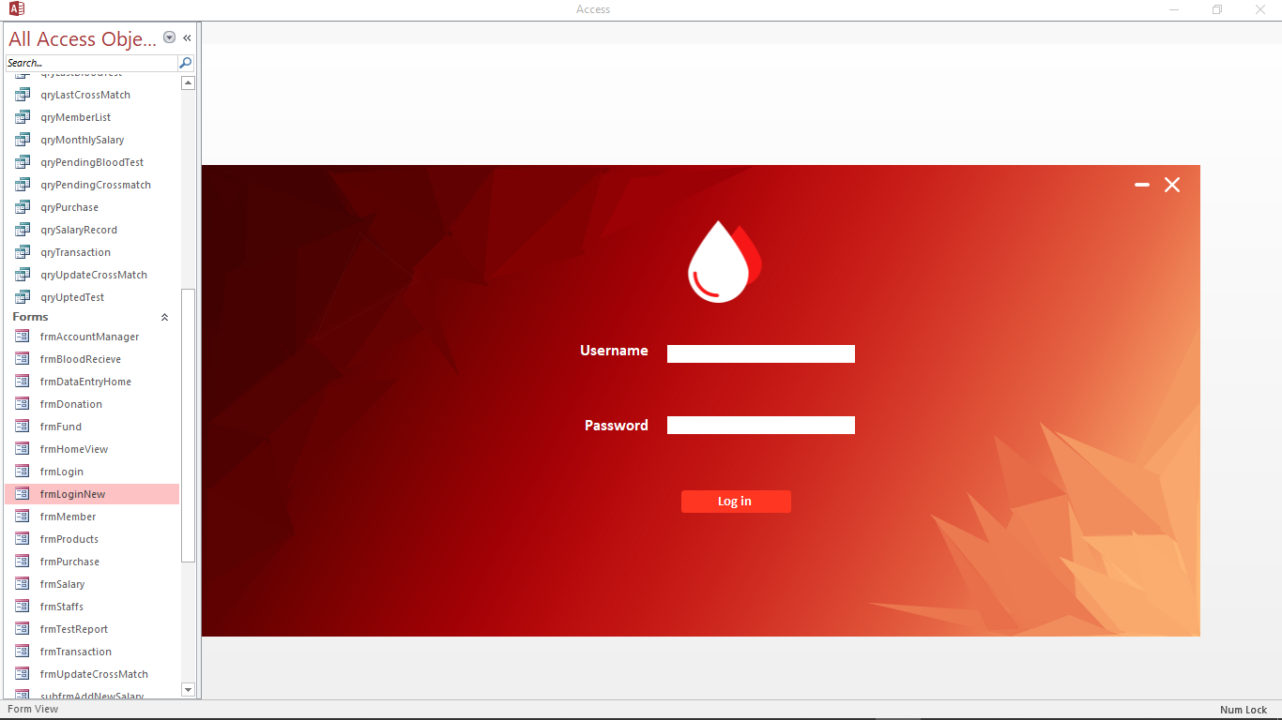Login Page

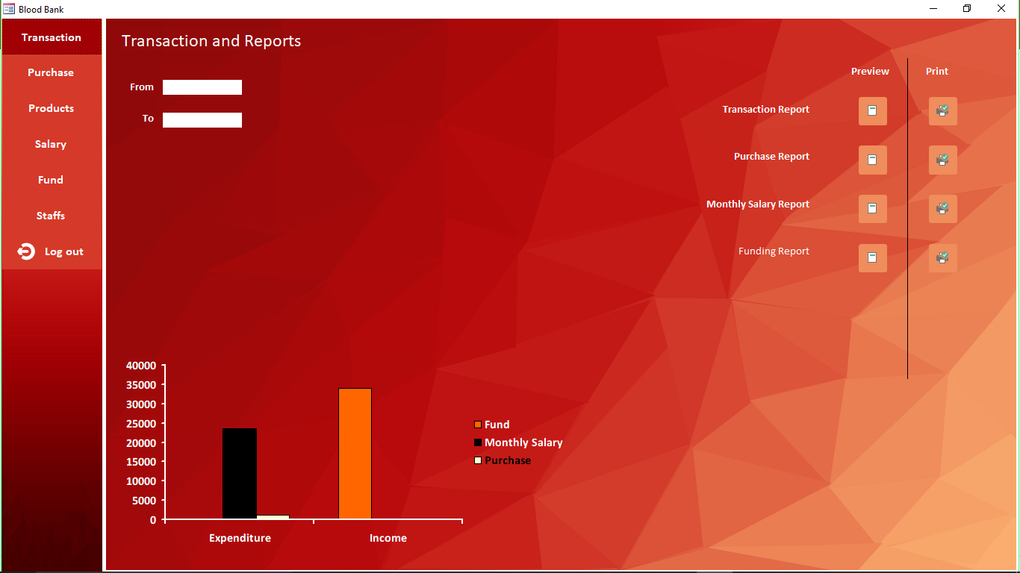Admin Page

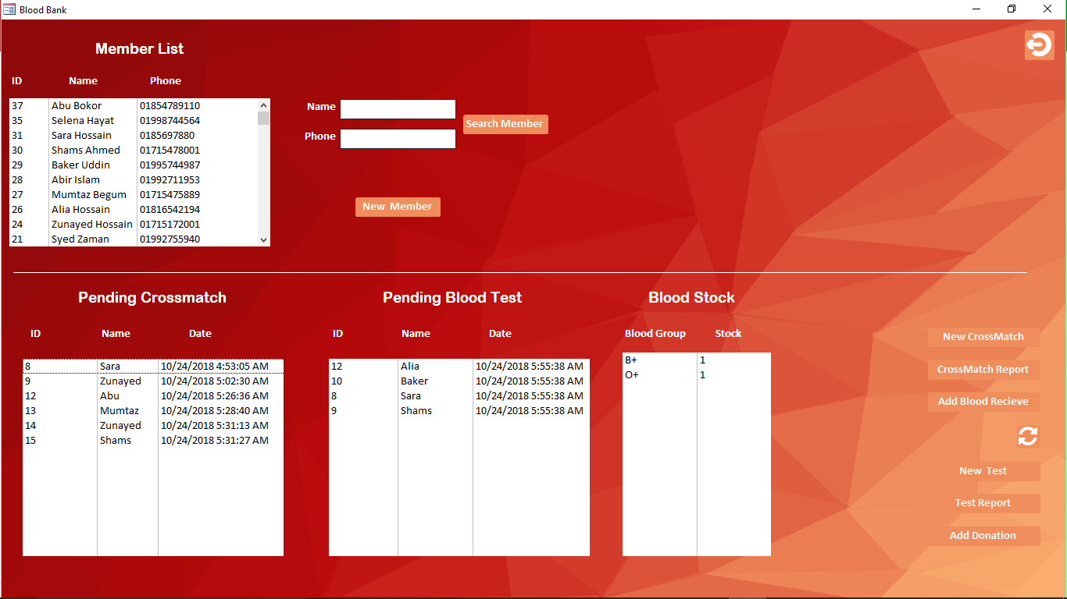Data Entry Operator Page

Report

# Report: rptBloodTest

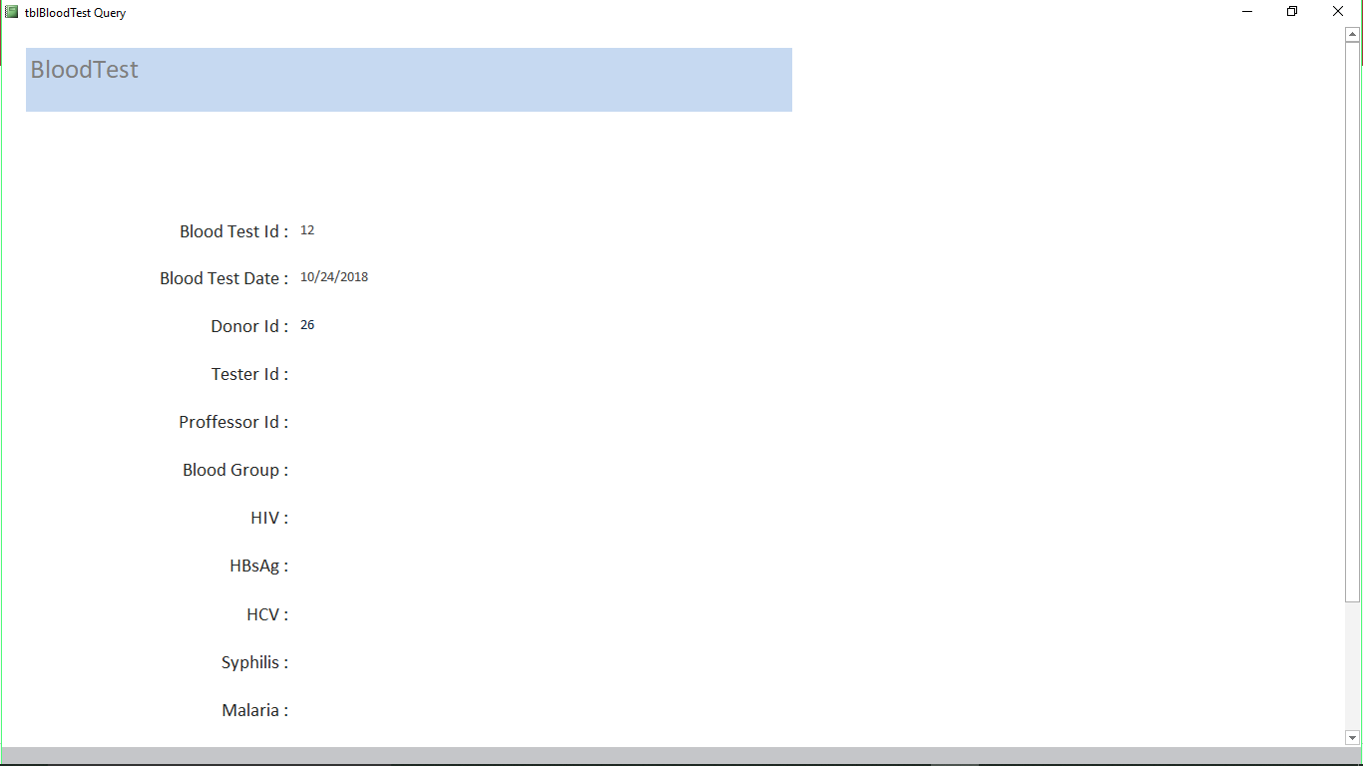

# Report: rptCrossMatch

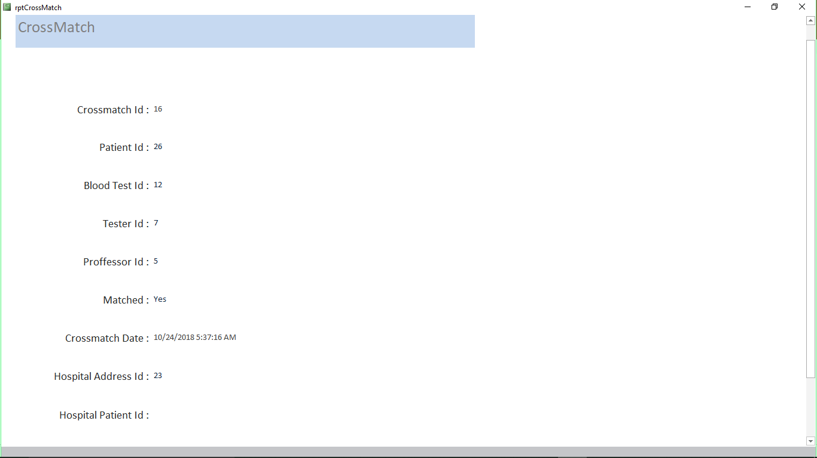

# Report: rptFunding

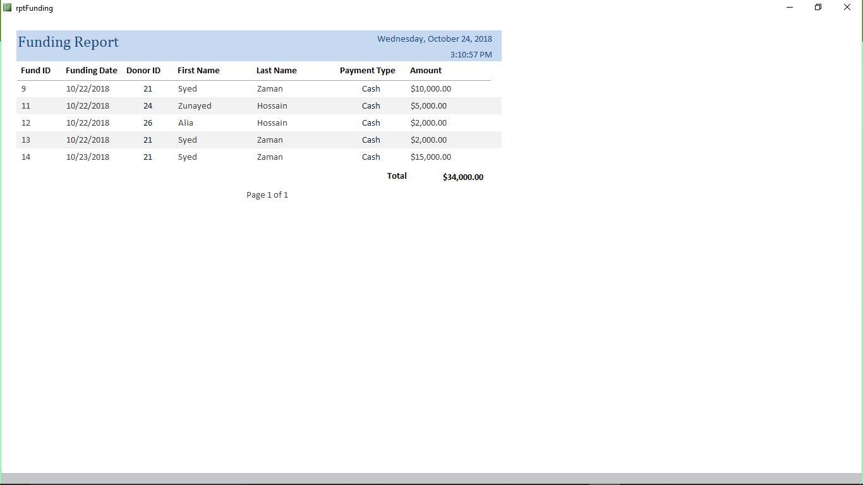

# Report: rptMonthlyReport

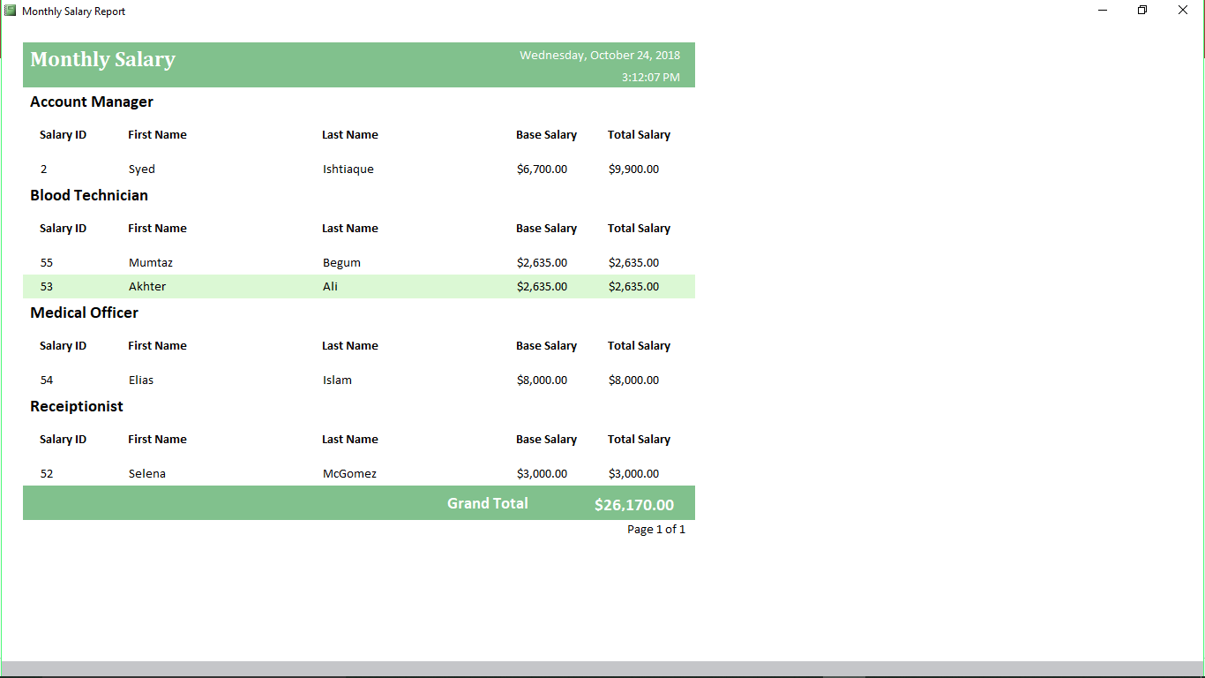

# Report: rptPurchase

# Report: rptTransaction

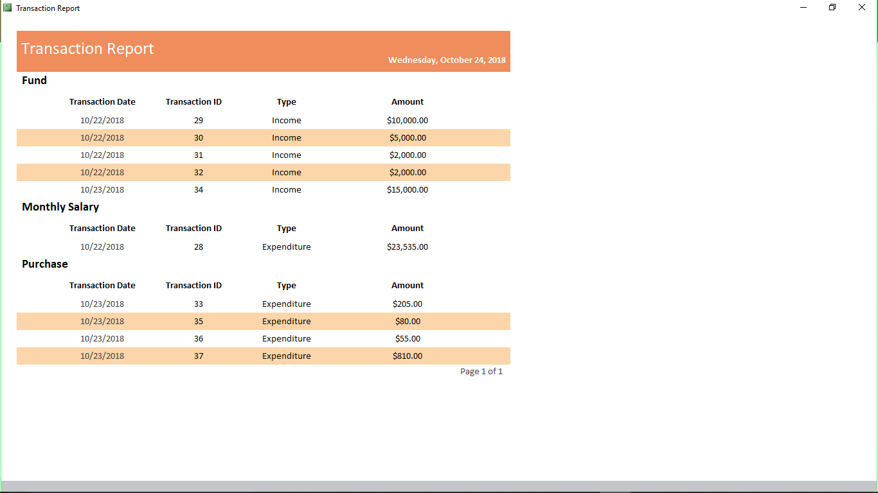

The End